12th AUSKF National Championship Tournament T-Shirt and Tenugui Sale

AUSKF will be taking pre-orders for tournament t-shirts and tenuguis.
The tournament committee requests that each federation submit 1 pre-order form by May 31, 2011.

T-shirts and tenuguis will be ready for pick-up on August 12, 2011 at the tournament location. Contact person for the federation will be notified.

T-Shirt
Sizes: adult XS – XXL (XS will fit youth)
Cost: $20
Color: Black 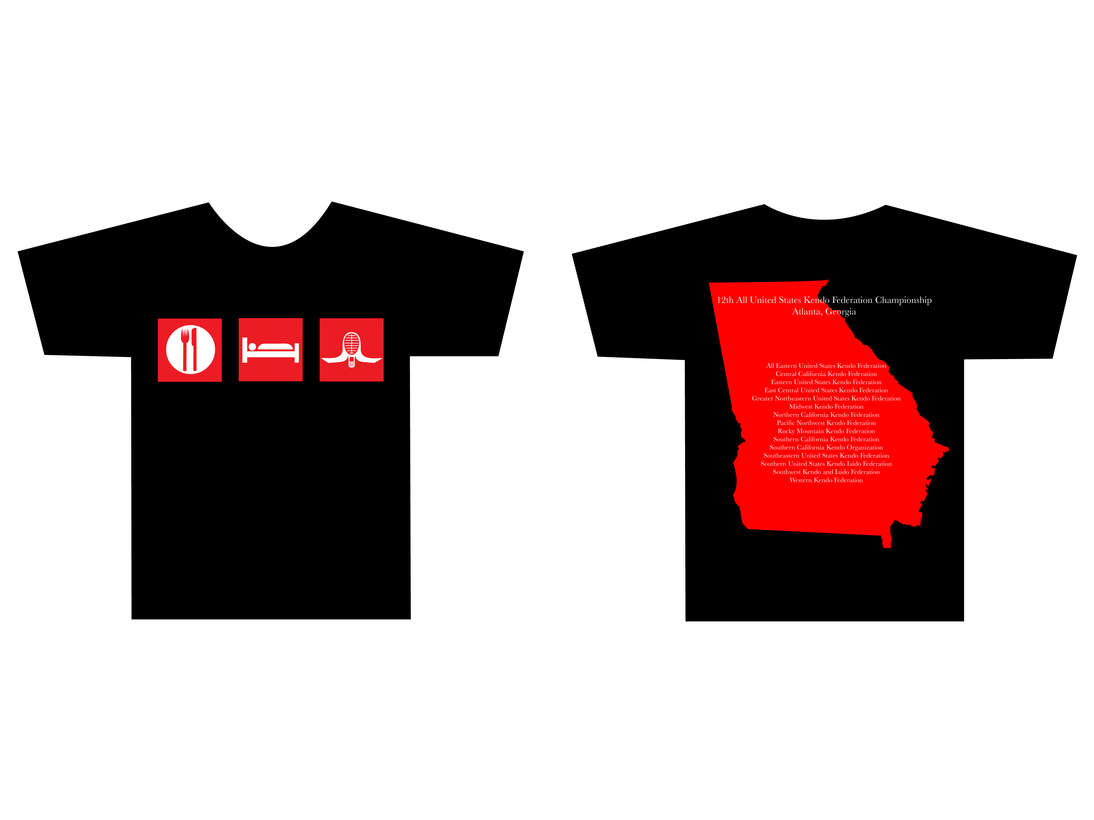
Front: Eat, Sleep, Kendo
Back: 12th AUSKF National Championships – Atlanta, Georgia
List of all participating Federations

Tenugui
Cost: $10.00
Color: Black
(Complimentary for ALL tournament participants)

T-Shirt and Tenugui Pre-Order Form
Please submit 1 form for your Federation

Federation name ______________________________________________
Contact name ________________________________________________
Phone number ________________________________________________
Email address _________________________________________________

T-Shirt Order
Sizes | X-Small | Small | Medium | Large | X-Large | XX-Large
Total order
Total cost
X $20.00

Total cost for ALL t-shirts $___________

Tenugui Order
*DO NOT include tournament participants in your order. ALL kenshi will receive a complimentary tenugui for participation in the tournament.

Total number ________ x $10.00 = ________ Total tenugui cost

Please make check payable to: All United States Kendo Federation
Submit this form and payment to Linda Tanaka by May 31, 2011.

Linda Tanaka
3144 Mabury Road
San Jose, CA 95127

Email: Muside2@yahoo.com

