Mushinkan Kendo Workshop
August 24 & 25, 2019
Enos Garcia Elementary School
305 Don Fernando St
Taos, NM 87571

Leading the Mushinkan workshop will be Ota Tadanori Sensei, Hanshi 8th Dan. Ota Sensei is a retired kendo program director of the Tokyo Metropolitan Police Department. He currently serves as the vice-chairman of the All Japan Dojo Renmei.

This is a very special workshop, as Ota Sensei has announced this to be his last trip abroad to instruct kendo. He wanted to end his world travels in Taos – a place of some of his most fond memories.
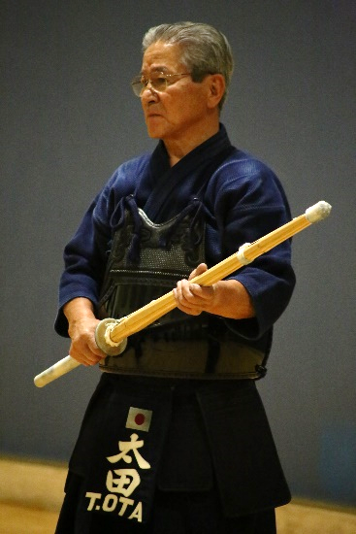

ABOUT THE WORKSHOP
- This will be a no-frills workshop. Instruction topics will include:
  - Kendo fundamentals & drills
  - Judging (4th Dan and above should bring their own shinpan-ki)
  - Bokuto ni Yoru Kendo Kihon Waza Keiko-ho
  - Kendo kata
- All participants are responsible for arranging their own flight, ground transportation, and lodging. There will be no group lodging arrangements made.
- Water will be provided. It is recommended to bring a sports bottle.
- Lunch will be ordered during the event – pizza likely for one day and some other type of takeout for the other day. Anyone partaking will be expected to contribute to cover the cost.
- There will be a reception Saturday night for drinks and socializing. The reception will be BYOB and snacks.
- There will be no promotion test offered.
- The workshop will run two full days, ending at 4:00 p.m. on Sunday. Departures should be schedule accordingly.

The workshop fee is $75 a day, or $125 for the two days.
PayPal is the preferred payment method. Simply go to www.paypal.me/Mushinkan

For those who do not have a PayPal account, payment may be made by check. Checks are to be made payable to Mushinkan.
Mail to: Mark Uchida
2375 So. Eudora St.
Denver, CO 80222
- If paying by mailed check, please include a note with your email address and/or a phone number that we can send workshop updates to.

There is no deadline. At-the-door payment will be accepted, but if possible, send an email to mushinkankendo@yahoo.com and cc adelajenmara@yahoo.com with a simple note letting us know you will be attending.

SCHEDULE
- For those arriving in Taos on Friday, August 23, there will be an open practice from 6:30 to 8:00 p.m.
- Saturday start @ 9:30 a.m. End @ 5:30 p.m.
  - Saturday Dinner: Everyone is responsible for their own dinner plans. There will be a reception at 8:30 for students to have a drink and mingle with Ota Sensei. Location of the reception will be announced during the workshop. The reception is BYOB (bring your own beverages) and snacks.
- Sunday start @ 9:30 a.m. End @ 4:00 p.m.

Questions should be emailed to:
mushinkankendo@yahoo.com AND adelajenmara@yahoo.com

