Dear Kendo Friends and Supporters:

Greetings from the All United States Kendo Federation. We are thrilled to announce the upcoming 4th Junior Open National Championship to be held in Henderson, Nevada June 23, 2013. The Championships in Henderson promises to be an exciting event, as the top prospects from all over the country will be coming together to test their skills in competition. Moreover, this tournament is OPEN to kids of all ages 18 and under, and we hope to motivate the next generation of U.S. kenshi by creating more opportunities for competition and friendship through kendo.

The cooperation and financial sponsorship from friends and supporters of kendo in the United States is a vital and invaluable component to the success of the Junior Open National Championships. We are respectfully asking for your support and contribution to the participants of the Championships.

Please make your check or money order payable to All United States Kendo Federation and send it together with your advertisement or artwork to:

Sandy Ghodgaonkar
736 W. Baker St #A1
Costa Mesa, CA 92626
Email: usjuniorkendoopen@gmail.com

Please find attached the Sponsorship Application and other information we will need if you would like to place an advertisement in the Program or create a banner for the Championships. Nishiki Sano will work with you to answer any questions and assemble the necessary information. Please email any questions you may have to usjuniorkendoopen@gmail.com. When sending an email, please put “Sponsorship” in the subject line. We look forward to a great Championship. Thank you in advance for your support.

Kind Regards,

Junior Open National Championships Committee

Type of contribution  Contribution |  |  | Details | Donation
A | Perpetual Trophy |  | Perpetual Trophy to the champion of any division (based on availability) Link/Ad on Front Page of Official Website as “Official Sponsor” | $500.00
B | Booth at Event |  | Approximately 10’x 10’ booth space with  One 6' table and 2 chairs to be provided | $300.00
C | Website Link |  | Link/Ad on Front Page of Official Website and Facebook page as “Official Sponsor” | $200.00
D | Banner |  | Banner inside Tournament Facility | $250.00
Championships Program Sponsor Opportunities
F | Platinum Sponsor | Advertising Banner + Full Page Ad (Color) + Link/Ad on Front Page of Official Website and booklet designated "Platinum Sponsor" |  | $1,000.00
G | Full page ad on cover | Full page Ad (Color) on the cover (inside cover, back inside, or back outside) |  | $750.00
H | Gold Sponsor | Full Page Ad (Color) + Name on front of booklet designated as "Gold Sponsor" |  | $400.00
I | Silver Sponsor | Half Page Ad (Color) + Name on front of booklet designated as "Silver Sponsor" |  | $250.00
J | Quarter Page Ad | Quarter Page Ad (Color) |  | $150.00
K |  | I will make a contribution of … |  | $
 |  | Total Sponsorship Amount: |  | $

Application Form

Please fill out the application form, and send it with your message, advertisement, art design, and/or photos together with the payment, to arrive by April 19, 2013. If you have any questions about placing advertisements or personal messages, or if you are interested in displaying and/or sampling your products in our booklet, please contact us at usjuniorkendoopen@gmail.com. Please make your check or money order payable to All United States Kendo Federation and send it together with your advertisement or artwork to:

Deadline: April 19, 2013

Name / Company :
Home Address :
Telephone Number :
Email :
Type of Sponsorship :
Total Sponsorship Amount : | $
Please check payable : | All United States Kendo Federation
Send to : | Sandy Ghodgaonkar
Home Address : | 736 W.Baker St #A1 Costa Mesa, CA 92626

Sponsorship Specifications
Booklet Advertisements

Advertisements and messages for the Championships Program can be submitted as a hard copy or by email. Please pay attention to the following:
➢ Graphics should be in COLOR
➢ Graphics and/or photos should be submitted at the HIGHEST possible resolution for best results.
➢ We may need to adjust the ad if the submitted file is unacceptable or will be sent back.
➢ Acceptable computer file formats are JPG, TIFF, PDF.
➢ Files will NOT be returned to you

Banners
All banners will measure 6 ft. x 2 ft. and be printed out on your behalf by the AUSKF.

Please provide your graphic, logo, and/or message according to the following specifications:
   ➢ Banner must be sent as a single page AI file. Only ILLUSTRATOR FILES will be accepted.
➢ Please specify banner orientation (horizontal/vertical)
➢ Files will NOT be returned to you. (No film/prints please).

[SAMPLE BANNER]

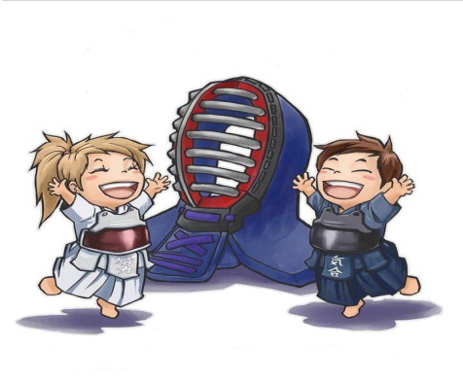

Good Luck at the Junior Open
National Championships!!

Las Vegas, NV
June 23, 2013
http://www. usjuniorkendoopen.com

