Dear fellow kenshi and iaidoka,

The Southern California Kendo Federation (SCKF) and Southern California Iaido Association (SCIA) are very pleased to host Katsuo ODA sensei from Shizuoka Prefecture, Japan. Oda sensei is a member of the Zen Nippon Kendo Renmei (ZNKR) Iaido Committee and carries the ranks of Hanshi 8 dan in iaido and Kyoshi 7 dan in kendo. He has traveled extensively throughout Europe, Australia, Canada, South America and here in the United States conducting seminars. Oda sensei most recently visited Southern California in 2011, 2012, and 2013.

Seminars will be held on the following dates and locations:

Friday (evening), March 6, 2015
Southeast Japanese School and Community Center (Norwalk Kendo Dojo), Norwalk, California.

Saturday, March 7, 2015
Orange County Buddhist Church, Multipurpose Building Gymnasium (OCB Kendo Dojo), Anaheim, California.

Sunday, March 8, 2015
Venice Japanese Community Center, Venice, California.

A shinsa will not be held this year.

The seminar schedule, fees, application/waiver form and additional information can be found in the pages to follow. All applications and fees must be received by Friday, February 27, 2015 or a late fee will be charged.

Please feel free to copy and distribute the package to any interested individuals.

If you have any questions or need additional information, please do not hesitate to contact me and I hope to see you in March!

Kind regards,

Dennis Ralutin
Southern California Iaido Association (SCIA)

Seminar Contact Information:

SCIA
c/o Dennis Ralutin
210 N. Hoover St.
Los Angeles, CA 90004

Phone: (213)793-6722
E-mail: dmralutin@yahoo.com

WINTER 2015 IAIDO SEMINAR INFORMATION

Guest Instructor: Katsuo ODA sensei
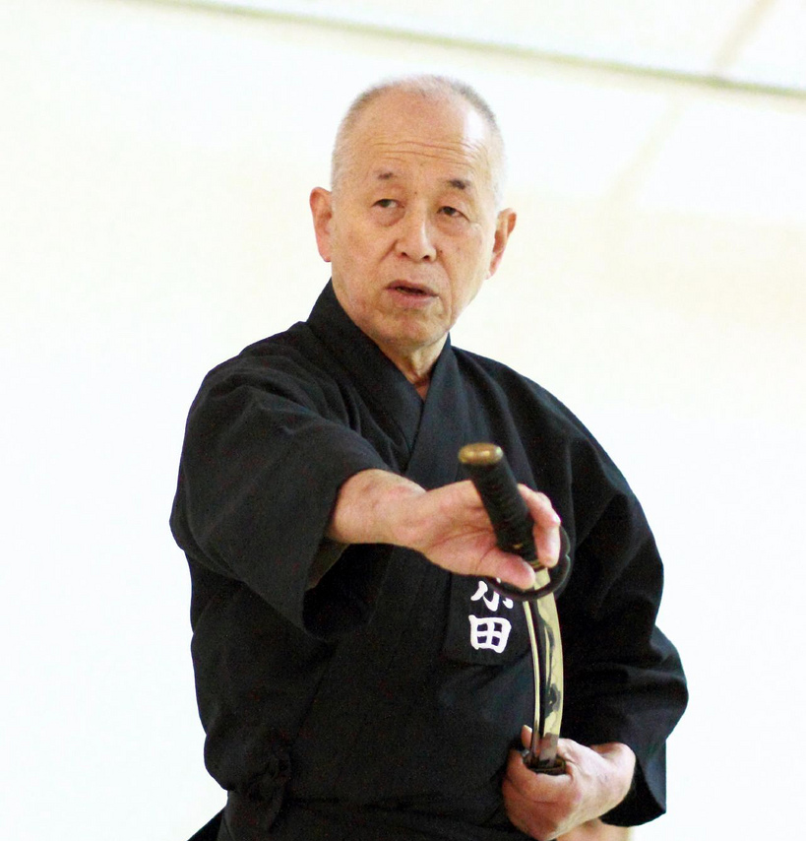
Iaido, Hanshi, 8 dan
Kendo, Kyoshi 7 dan
Member, Zen Nippon Kendo Renmei (ZNKR) Iaido Committee
Chairman, Shizuoka Iaido Renmei, Shizuoka Prefecture, Japan
Technical Advisor, Australian Kendo Renmei

Tentative Schedule

Friday, March 6, 2015, Norwalk Kendo Dojo
7:30 p.m. – 9:30 p.m.: Seminar

Saturday, March 7, 2015, OCB Kendo Dojo
9:00 a.m. – 12:00 a.m.: Seminar
12:00 p.m. – 1:00 p.m.: Lunch
1:00 p.m. – 4:00 p.m.: Seminar
5:00 p.m. – 8:00 p.m.: Dinner; location TBD

Sunday, March 8, 2015, Venice Japanese Community Center
9:00 a.m. – 12:00 a.m.: Seminar
9:00 a.m. – 12:00 a.m.: Seminar
12:00 p.m. – 1:00 p.m.: Lunch
1:00 p.m. – 4:00 p.m.: Seminar

Fees:

Seminar: $75.00 for 3/6/15, 3/7/15, and 3/8/15
$30.00 for 3/7/15 only or 3/8/15 only
Bento lunch (optional): $10.00, 3/7/15 and 3/8/15 only
Dinner, 3/7/15 (optional): Price and location TBD

Late fee: $10.00 for applications received after 2/27/15

Additional Information: The seminar will be conducted according to the Zen Nippon Kendo Renmei (ZNKR) standards on seitei iaido. All participants must be familiar with the ZNKR seitei iaido kata (ZenKenRen iai). Due to safety reasons, shinken (swords with a sharp edge) will not be allowed. All equipment must be in good working order and will be subject to inspection at anytime.

WINTER 2015 IAIDO SEMINAR APPLICATION / WAIVER FORM

(Please print all information)

Name ______________________________________________________________________ Rank _______________________________

AUSKF ID Number (if applicable) _______________________ Regional Kendo Federation (if applicable) ________________________

Dojo ________________________________________________________Brthdate (MM / DD / YYYY) ____________________________

Home Address ___________________________________________________________________________________________________

________________________________________________________________________________________________________________

Telephone (Primary) ______________________________________Telephone (Secondary) ____________________________________

E-mail Address __________________________________________________________________________________________________

Emergency Contact & Phone Number _______________________________________________________________________________

________________________________________________________________________________________________________________

Name of Parent or Guardian (If under 18 years of age) __________________________________________________________________

Waiver of Liability (Please read and sign below)

I, the undersigned, do hereby voluntarily submit my application for participation and attendance in the Winter 2015 Southern California Iaido Association (SCIA) Seminar, and hereby release all rights or claims for any injuries, loss of, or damage to personal property that I may incur while attending and participating in the aforementioned event. I hereby waive any and all claims against the All United States Kendo Federation (AUSKF), the Southern California Kendo Federation (SCKF), the Orange County Buddhist Church, Southeast Japanese School and Community Center, the Venice Japanese Community Center, and the SCIA or any officials, agents, representatives, successors, and assignees of those individuals or organizations arranging or conducting said event. I further state that I am in good health and physical condition so that I may participate in said event. If I am under 18 years of age, this release and consent must also be signed by a parent or legal guardian.

Signature ________________________________________________________________ Date __________________________________

Signature of Parent or Guardian (if under 18 years of age) ______________________________________________________________

WINTER 2015 IAIDO SEMINAR FEE SCHEDULE

Seminar (enter number attending):

3/6/15, 3/7/15, and 3/8/15: ___ X $75.00

One day only, 3/7/15 or 3/8/15: ___ X $30.00

Bento (enter number requested):

3/7/15: ___ X $10.00

3/8/15: ___ X $10.00

Dinner (enter number attending):

3/7/15: ___ X $35.00

Late Fee:

After 2/27/15: ___ X $10.00

Total Enclosed: $ ___________

Please make check payable to Southern California Iaido Association (do not abbreviate) and send it along with your application/waiver form and this completed fee schedule to the address below no later than Friday, February 27, 2015. A late fee of $10.00 will be charged for applications received after the deadline.

SCIA
c/o Dennis Ralutin
210 N. Hoover St.
Los Angeles, CA 90004

WINTER 2015 IAIDO SEMINAR LOCATION INFORMATION (3/6/15)

Southeast Japanese School and Community Center (Norwalk Kendo Dojo)
14615 S. Gridley Rd.
Norwalk, CA 90650
http://www.eanet.com/norwalk

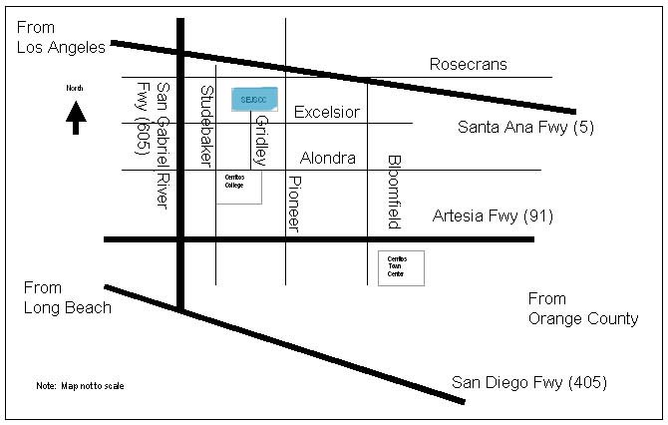

Directions

From the north
- I-605 south
- Exit Rosecrans Ave.
- Left on Rosecrans Ave., heading east
- Right on Studebaker Rd., heading south
- Left on Excelsior Dr., heading east
- Left on Gridley Rd., heading north
- Parking lot entrance is at the end of Gridley Rd.

From the south
- I-605 north
- Exit Alondra Bl.
- Right on Alondra Bl., heading east
- Left on Gridley Rd., heading north
- Parking lot entrance is at the end of Gridley Rd.

Local Airport Distances from Norwalk Kendo Dojo (approximate)

- Long Beach Airport (LGB): 13 miles
- Los Angeles International Airport (LAX): 21 miles
- John Wayne Orange County International Airport (SNA): 25 miles

WINTER 2013 IAIDO SEMINAR LOCATION INFORMATION (3/7/15)

Orange County Buddhist Church (OCB Kendo Dojo)
909 S. Dale Ave.
Anaheim, CA 92804
http://www.ocbkendo.com

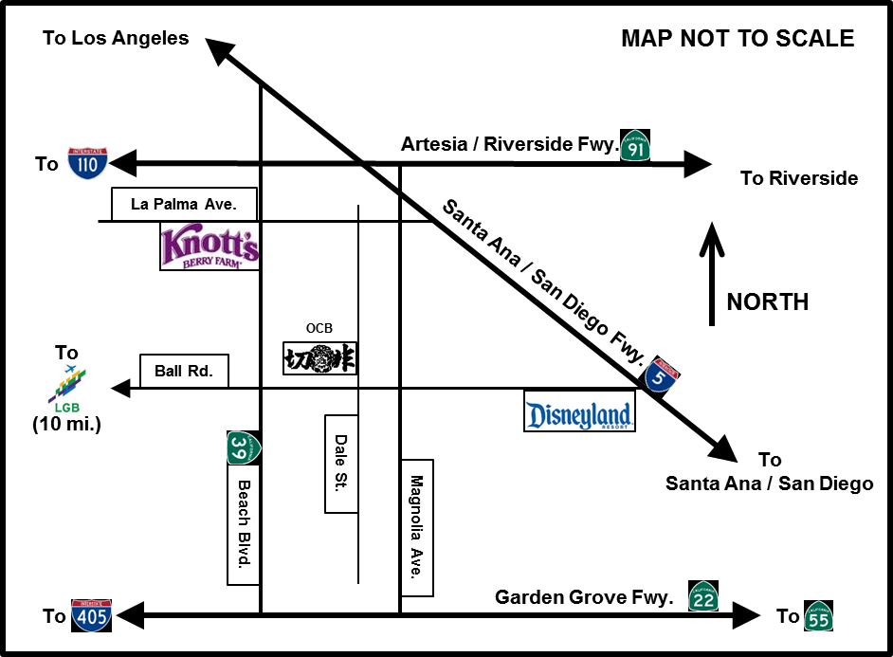

Directions

- OCB Kendo Dojo can be reached from the Santa Ana / San Diego Freeway (I-5), Artesia / Riverside Freeway (CA-91), or Garden Grove Freeway (CA-22) by getting off at either Beach Blvd. or Magnolia Ave.
- From the I-5 or CA-91, go south to Ball Rd.
- From the CA-22, go north to Ball Rd.
- From Beach Blvd., go east on Ball Road and turn left on Dale St., which is at the first light.
- From Magnolia Ave., go west on Ball Road and turn right on Dale St., which is at the first light.
- Head north on Dale St. for a few yards and turn left into the church parking lot.
- The dojo is on the south side of the parking lot in the Multipurpose Building (MPB) gymnasium. The MPB is across the parking lot from the classrooms, Social Hall, and Hondo (worship hall).

Local Airport Distances from OCB Kendo Dojo (approximate)

- Long Beach Airport (LGB): 10 miles (via Ball Rd. and Wardlow Rd.)
- John Wayne Orange County International Airport (SNA): 17 miles
- Los Angeles International Airport (LAX): 32 miles

WINTER 2013 IAIDO SEMINAR LOCATION INFORMATION (3/8/15)

Venice Japanese Community Center
12448 Braddock Dr.
Los Angeles, CA 90066
http://vjcc.com/

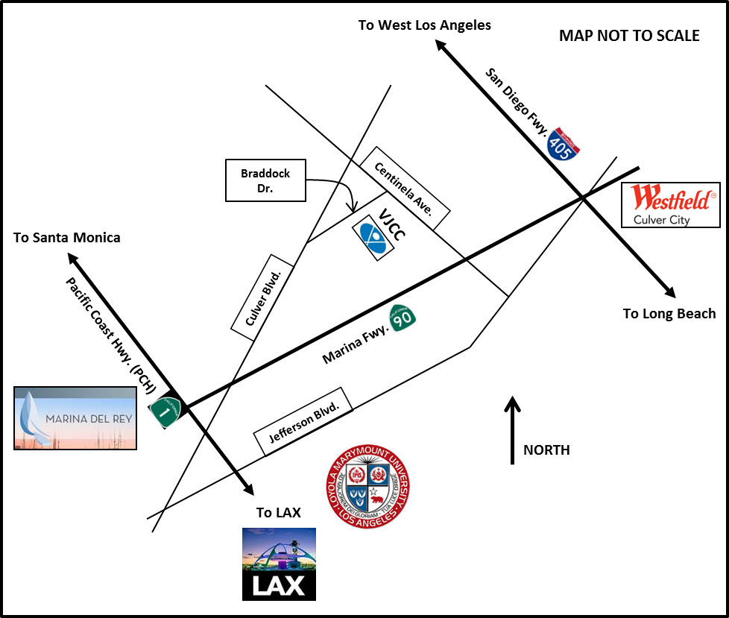

Directions

From the I-405
- CA-90 west towards Marina Del Rey
- Exit Centinela Ave.
- Right on Centinela Ave., heading northwest
- Left on Braddock Dr., heading southwest
- Parking lot entrance is on the left

Local Airport Distances from Venice Japanese Community Center (approximate)

- Los Angeles International Airport (LAX): 4 miles
- Bob Hope / Burbank Airport (BUR): 24 miles
- Long Beach Airport (LGB): 29 miles
- John Wayne Orange County International Airport (SNA): 45 miles

All participants are responsible for their own transportation and lodging.

