February 1, 2016

Dear fellow kenshi and iaidoka,

The Southern California Kendo Federation (SCKF) is very pleased to host Katsuo ODA sensei from Shizuoka Prefecture, Japan. Oda Sensei is a member of the Zen Nippon Kendo Renmei (ZNKR) Iaido Committee and carries the ranks of Hanshi 8 dan in iaido and Kyoshi 7 dan in kendo. He has traveled extensively throughout Europe, Australia, Canada, South America and here in the United States conducting seminars. Oda Sensei most recently visited Southern California in 2011, 2012, 2013, and 2015.

Iaido seminars will be held on the following dates at the Orange County Buddhist Church, Multipurpose Building Gymnasium (OCB Kendo Dojo) in Anaheim, California:

Friday (evening), March 18, 2016
Saturday, March 19, 2016

The annual North / South (California) Kendo Tournament will be held on Sunday, March 20, 2016 at the Dee Hardison Sports Center at Wilson Park in Torrance, California. Oda Sensei will be attending this tournament as an honored guest. An iaido demonstration featuring members from the Northern California Kendo Federation (NCKF) and SCKF will take place during the opening ceremonies. Tournament entry is limited to NCKF and SCKF members only, but all spectators are welcome. Additional tournament information is being sent in a separate packet and is posted on the SCKF website for those interested in attending.

The seminar schedule, fees, application/waiver form and additional information can be found in the pages to follow. All applications and fees must be received by Friday, March 4, 2016 or a late fee will be charged.

Please feel free to copy and distribute the package to any interested individuals.

If you have any questions or need additional information, please do not hesitate to contact me and I look forward to seeing you in March!

Kind regards,

Dennis Ralutin
Chairman, SCKF Iaido

Seminar Contact Information:

SCKF Iaido
c/o Dennis Ralutin
210 N. Hoover St.
Los Angeles, CA 90004

Phone: (213)793-6722
E-mail: dmralutin@yahoo.com

2016 ODA SENSEI IAIDO SEMINAR INFORMATION

Seminar Instructor: Katsuo ODA Sensei
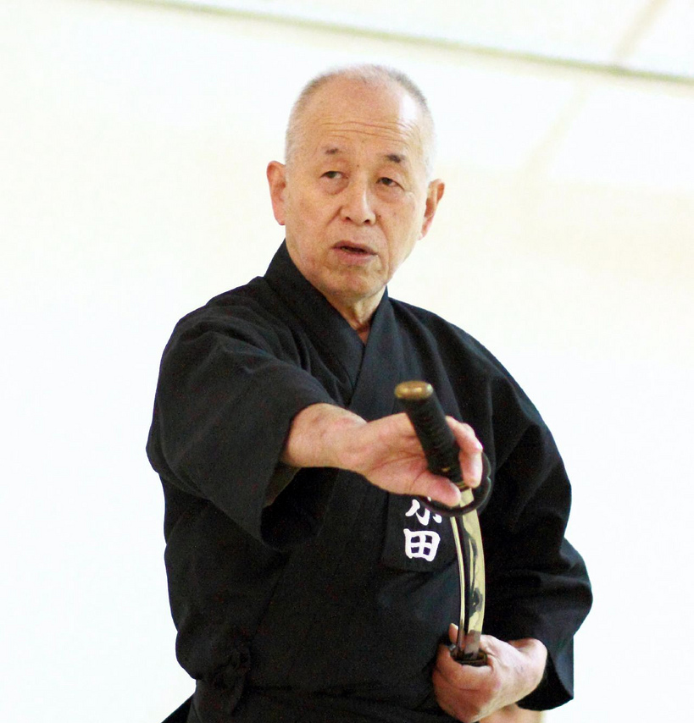
Iaido, Hanshi, 8 dan
Kendo, Kyoshi 7 dan
Member, Zen Nippon Kendo Renmei (ZNKR) Iaido Committee
Chairman, Shizuoka Iaido Renmei, Shizuoka Prefecture, Japan
Technical Advisor, Australian Kendo Renmei

Schedule (subject to change)

Friday, March 18, 2016, OCB Kendo Dojo
5:30 p.m. – 9:30 p.m.: Seminar

Saturday, March 19, 2016, OCB Kendo Dojo
9:00 a.m. – 12:00 a.m.: Seminar
12:00 p.m. – 1:00 p.m.: Lunch
1:00 p.m. – 4:00 p.m.: Seminar
5:00 p.m. – 8:00 p.m.: Dinner; location TBD

Sunday, March 20, 2016, Dee Hardison Sports Center, Wilson Park
9:00 a.m. – 10:00 a.m.: Opening ceremonies; iaido demonstration
10:00 a.m. – 5:00 p.m.: Kendo tournament
Please visit the SCKF website for additional tournament information: http://www.eanet.com/sckf/

Fees:

Seminar: $25.00 for one or both days; no daily fee
Bento lunch (optional): $10.00, 3/19/16 only
Dinner, 3/19/16 (optional): Location and price per person, TBD
Late fee: $10.00 for applications received after 3/4/16

Additional Information: The seminar will be conducted according to the Zen Nippon Kendo Renmei (ZNKR) standards on seitei iaido. All participants must be familiar with the ZNKR seitei iaido kata (ZenKenRen iai). Due to safety reasons, shinken (swords with a sharp edge) will not be allowed. All equipment must be in good working order and will be subject to inspection at anytime.

2016 ODA SENSEI IAIDO SEMINAR APPLICATION / WAIVER FORM AND FEE INFORMATION

(Please print all information)

Name ______________________________________________________________________ Rank _______________________________

AUSKF ID Number (if applicable) _______________________ Regional Kendo Federation (if applicable) ________________________

Dojo ________________________________________________________Brthdate (MM / DD / YYYY) ____________________________

Telephone (Primary) ______________________________________Telephone (Secondary) ___________________________________

E-mail Address __________________________________________________________________________________________________

Emergency Contact & Phone Number _______________________________________________________________________________

________________________________________________________________________________________________________________

Name of Parent or Guardian (If under 18 years of age) _________________________________________________________________

Waiver of Liability (Please read and sign below)

I, the undersigned, do hereby voluntarily submit my application for participation and attendance in the 2016 Oda Sensei Iaido Seminar, and hereby release all rights or claims for any injuries, loss of, or damage to personal property that I may incur while attending and participating in the aforementioned event. I hereby waive any and all claims against the All United States Kendo Federation (AUSKF), the Southern California Kendo Federation (SCKF), the Orange County Buddhist Church, or any officials, agents, representatives, successors, and assignees of those individuals or organizations arranging or conducting said event. I further state that I am in good health and physical condition so that I may participate in said event. If I am under 18 years of age, this release and consent must also be signed by a parent or legal guardian.

Signature ________________________________________________________________ Date __________________________________

Signature of Parent or Guardian (if under 18 years of age) ______________________________________________________________

Seminar (enter number attending): ___ X $25.00

Bento, 3/19/16 (enter number requesting): ___ X $10.00

Dinner, 3/19/16 (if yes, enter number attending): ___ Yes ___ No

Late Fee (after 3/4/16): ___ X $10.00

Total Enclosed: $ ___________

Please make check payable to Southern California Kendo Federation (do not abbreviate) and send it along with your application/waiver form and this completed fee schedule to the address below no later than Friday, March 4, 2016. A late fee of $10.00 will be charged for applications received after the deadline.

SCKF Iaido
c/o Dennis Ralutin
210 N. Hoover St.
Los Angeles, CA 90004

2016 ODA SENSEI IAIDO SEMINAR LOCATION

Orange County Buddhist Church (OCB Kendo Dojo)
909 S. Dale Ave.
Anaheim, CA 92804
http://www.ocbkendo.com

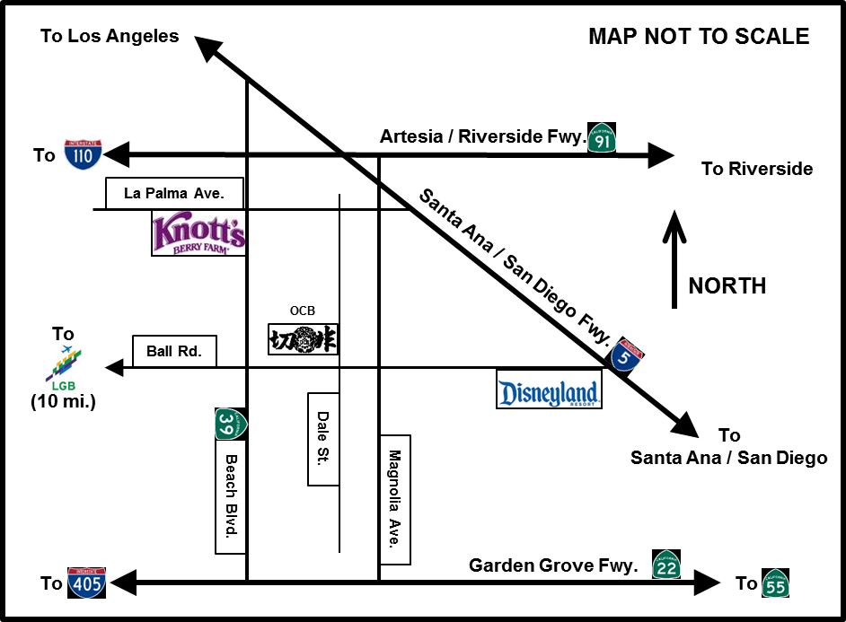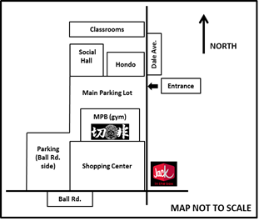

Directions

- OCB Kendo Dojo can be reached from the Santa Ana / San Diego Freeway (I-5), Artesia / Riverside Freeway (CA-91), or Garden Grove Freeway (CA-22) by getting off at either Beach Blvd. or Magnolia Ave.
- From the I-5 or CA-91, go south to Ball Rd.
- From the CA-22, go north to Ball Rd.
- From Beach Blvd., go east on Ball Road and turn left on Dale St., which is at the first light.
- From Magnolia Ave., go west on Ball Road and turn right on Dale St., which is at the first light.
- Head north on Dale St. for a few yards and turn left into the church parking lot.
- The dojo is on the south side of the parking lot in the Multipurpose Building (MPB) gymnasium. The MPB is across the parking lot from the classrooms, Social Hall, and Hondo (worship hall).

Local Airport Distances from OCB Kendo Dojo (approximate)

- Long Beach Airport (LGB): 10 miles (via Ball Rd. and Wardlow Rd.)
- John Wayne Orange County International Airport (SNA): 17 miles
- Los Angeles International Airport (LAX): 32 miles

All participants are responsible for their own transportation and lodging. There is a wide selection of hotels within a five mile radius of the dojo, especially around the Knott’s Berry Farm and Disney Resort areas.

2016 NORTH / SOUTH KENDO TOURNAMENT LOCATION

Dee Hardison Sports Center
Charles H. Wilson Park
2400 Jefferson St.
Torrance, CA 90501
http://www.torranceca.gov/29398.htm

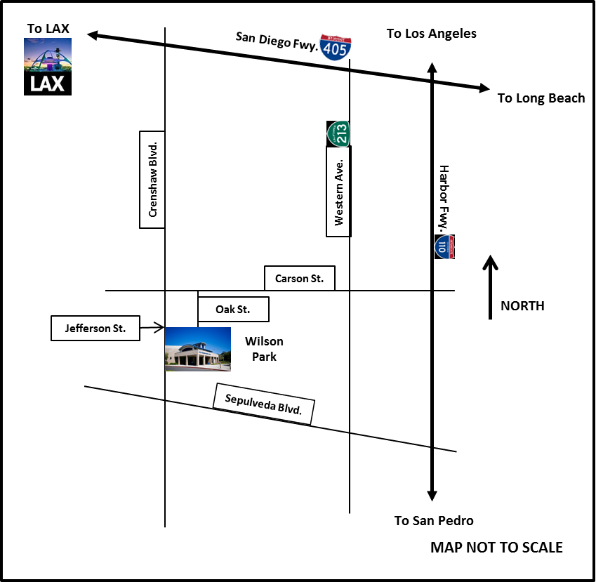

Directions

- From 405 fwy: take Crenshaw exit south, turn east at Jefferson
- From 110 fwy: take Carson exit west, turn south on Crenshaw, then turn east at Jefferson (or from Carson, turn south on Oak St., just before Crenshaw)

Local Airport Distances from Wilson Park (approximate)

- Los Angeles International Airport (LAX): 12 miles
- Long Beach Airport (LGB): 14 miles
- John Wayne Orange County International Airport (SNA): 35 miles

